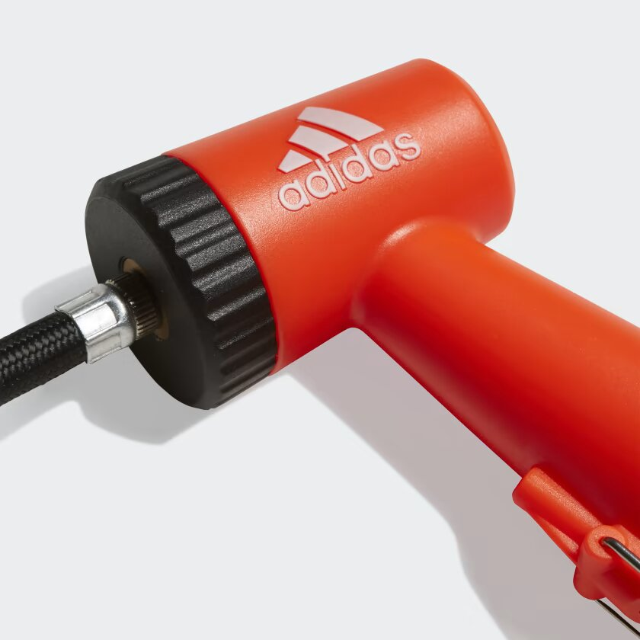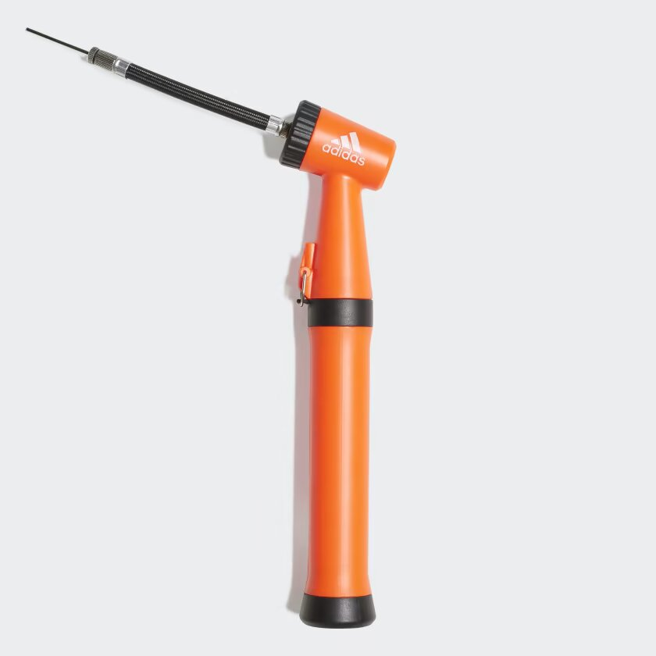

ADIDAS AIR PUMP

**A DUAL-ACTION PUMP THAT KEEPS YOU READY TO ROLL.**

Don't let a flat spoil your fun. Whether you're on the five-aside court, training field or pitch, this air pump ensures your soccer ball stays fully inflated. It has a dual action design, which means it inflates both on the push and pull.

**DETAILS:**

* Polypropylene
* Pumps air on upstroke and downstroke
* Includes one needle
* Includes additional air hose
* Imported
* Product color: Black / White / Solar Red
* Product code: CZ9556